**JEREMY PETERSON DUTOYA**

**DR. MOHAMMAD AWWAL**

**PMBA-8317-RHB APPLIED DATA MANAGEMENT FOR BUSINESS USERS**

## LAB 1 – EXECUTE BASIC SQL STATEMENTS

1. Find the name of the user connected to the database:

→ SHOW USER;

1. Find today's date as Oracle’s default date format:

→ SELECT sysdate FROM dual;

Format the data output with date and time as MM/DD/YYY HH:MI:SS

→ SELECT TO_CHAR(sysdate, 'MM/DD/YYY HH:MI:SS') FROM dual;

1. Find the column names of all five tables: retail_order, order_item, sku_data, inventory using DESC tablename

→ DESC retail_order;

DESC order_item;

DESC sku_data;

DESC inventory;

DESC warehouse;

1. Use a SELECT statement to display all columns and all rows from SKU_DATA table using wild card (‘*’)

→ SELECT * FROM sku_data;

1. Write a query to display any three columns for all rows from the SKU_DATA table.

→ SELECT sku, sku_description, department FROM sku_data;

1. Repeat Q4 & 5 for rest of the tables in Q3

→ SELECT * FROM retail_order;

SELECT ordernumber, ordermonth, orderyear FROM retail_order;

SELECT * FROM order_item;

SELECT ordernumber, quantity, price FROM order_item;

SELECT * FROM inventory;

SELECT warehouseid, sku_description,quantityonhand FROM inventory;

SELECT * FROM warehouse;

SELECT warehouseid, warehousecity, manager FROM warehouse;

1. Write a query to display sku_description and buyer from sku_data table for department = ‘Water Sports’ (Hint, you will need to use Where clause)

→ SELECT sku_description, buyer FROM sku_data

WHERE department='Water Sports';

1. Write a query to display sku_description and buyer from **sku_data** table for department = ‘Climbing’ and buyer = ‘Jerry Martin’ (Hint, you will need to use Where with AND clause)

→ SELECT sku_description, buyer FROM sku_data

WHERE (department='Climbing') AND (buyer='Jerry Martin');

1. Write a query to display sku_description and buyer from **sku_data** table for department = ‘Water Sports’ OR buyer = ‘Jerry Martin’ (Hint, you will need to use Where with OR clause)

→ SELECT sku_description, buyer, FROM sku_data

WHERE (department='Water Sports') OR (buyer='Jerry Martin');

1. Use **comparison operators** on numeric data.
   1. Write a SQL statement to display all columns for all rows from **SKU_DATA** with SKU >200000

→ SELECT * FROM sku_data

WHERE sku>200000;

* 1. Write a query to display all columns from **order_item** table for order quantity > 1. (Hint, you will need to use the Where clause as Where quantity>1)

→ SELECT * FROM order_item

WHERE quantity>1;

1. Use of ROWNUM to limit number of rows to display. (used in Oracle only), For example, if you want to display only 4 rows from SKU_DATA: SELECT * from SKU_DATA WHERE rownum <5;
   1. Write a query to display all columns and only 2 rows from **order_item** table.

→ SELECT * from order_item

WHERE rownum<3;

* 1. Write a SQL statement to display all columns for all rows from **SKU_DATA** with SKU >200000 and limit the output to 5 rows. **Sort the output** by ascending order by sku_description. (Hint. Need to use ORDER by clause)

→ SELECT * from SKU_DATA

WHERE (rownum<6) AND (SKU>200000)

ORDER BY SKU_DESCRIPTION ASC;

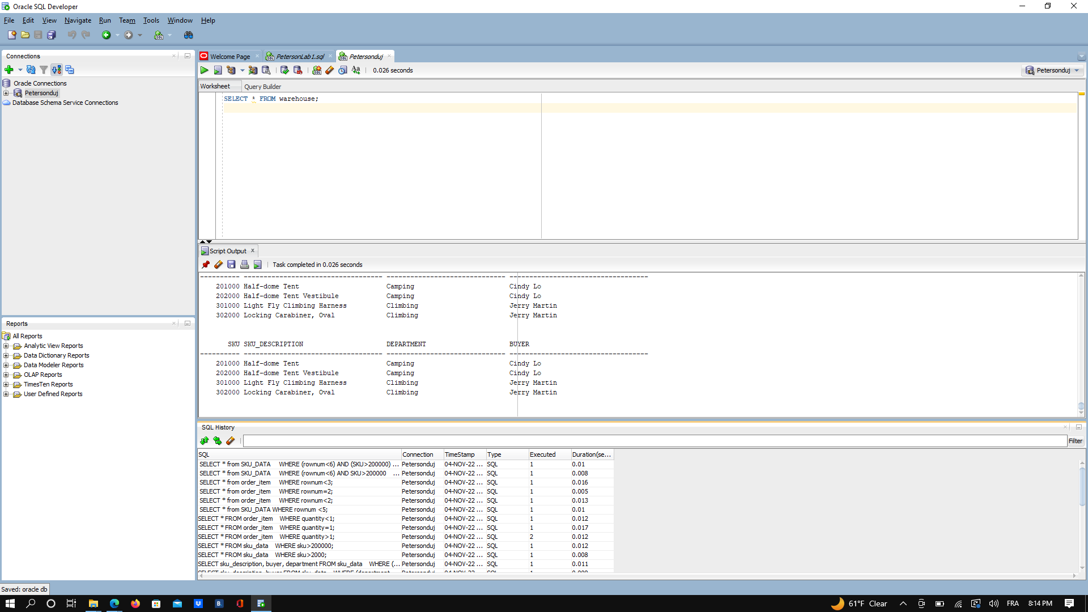

*Figure 1 - Screenshot of the Oracle SQL Developper Scipt output and SQL History*

SQL HISTORY:

**SQL Connection TimeStamp Type Duration**

|  |  |  |  |  |  |
| --- | --- | --- | --- | --- | --- |
| SELECT * from SKU_DATA WHERE (rownum<6) AND (SKU>200000) ORDER BY SKU_DESCRIPTION ASC; | Petersonduj | 1667598163218 | SQL | 1 | 0.01 |
| SELECT * from SKU_DATA WHERE (rownum<6) AND SKU>200000 ORDER BY SKU_DESCRIPTION ASC; | Petersonduj | 1667598035488 | SQL | 1 | 0.008 |
| SELECT * from order_item WHERE rownum<3; | Petersonduj | 1667597845924 | SQL | 1 | 0.016 |
| SELECT * from order_item WHERE rownum=2; | Petersonduj | 1667597835824 | SQL | 1 | 0.005 |
| SELECT * from order_item WHERE rownum<2; | Petersonduj | 1667597819035 | SQL | 1 | 0.013 |
| SELECT * from SKU_DATA WHERE rownum <5; | Petersonduj | 1667597764971 | SQL | 1 | 0.01 |
| SELECT * FROM order_item WHERE quantity<1; | Petersonduj | 1667597697624 | SQL | 1 | 0.012 |
| SELECT * FROM order_item WHERE quantity=1; | Petersonduj | 1667597684594 | SQL | 1 | 0.017 |
| SELECT * FROM order_item WHERE quantity>1; | Petersonduj | 1667597704032 | SQL | 2 | 0.012 |
| SELECT * FROM sku_data WHERE sku>200000; | Petersonduj | 1667597133226 | SQL | 1 | 0.012 |
| SELECT * FROM sku_data WHERE sku>2000; | Petersonduj | 1667597107739 | SQL | 1 | 0.008 |
| SELECT sku_description, buyer, department FROM sku_data WHERE (department='Water Sports') OR (buyer='Jerry Martin'); | Petersonduj | 1667596944516 | SQL | 1 | 0.011 |
| SELECT sku_description, buyer FROM sku_data WHERE (department='Water Sports') OR (buyer='Jerry Martin'); | Petersonduj | 1667596919238 | SQL | 1 | 0.008 |
| SELECT sku_description, buyer FROM sku_data WHERE department='Water Sports' OR buyer='Jerry Martin'; | Petersonduj | 1667596874075 | SQL | 1 | 0.011 |
| SELECT sku_description, buyer FROM sku_data WHERE department='Climbing' AND buyer='Jerry Martin'; | Petersonduj | 1667596783615 | SQL | 1 | 0.008 |
| SELECT sku_description, buyer FROM sku_data WHERE department='Water Sports'; | Petersonduj | 1667596511288 | SQL | 1 | 0.004 |
| SELECT warehouseid, warehousecity, manager FROM warehouse; | Petersonduj | 1667596318258 | SQL | 1 | 0.011 |
| SELECT warehouseid, sku_description,quantityonhand FROM inventory; | Petersonduj | 1667596225044 | SQL | 1 | 0.019 |
| SELECT ordernumber, quantity, price FROM order_item; | Petersonduj | 1667595742925 | SQL | 1 | 0.01 |
| SELECT ordernumber, ordermonth, orderyear FROM retail_order; | Petersonduj | 1667595553303 | SQL | 1 | 0.014 |
| SELECT * FROM retail_order; | Petersonduj | 1667595163967 | SQL | 1 | 0.004 |
| SELECT * FROM warehouse; | Petersonduj | 1667596271344 | SQL | 2 | 0.014 |
| SELECT * FROM inventory; | Petersonduj | 1667595819872 | SQL | 2 | 0.024 |
| SELECT * FROM sku_data; | Petersonduj | 1667594451352 | SQL | 1 | 0.021 |
| SELECT * FROM order_item; | Petersonduj | 1667594419271 | SQL | 1 | 0.011 |
| SELECT SKU, SKU_DESCRIPTION, DEPARTMENT FROM SKU_DATA; | Petersonduj | 1667593824347 | SQL | 1 | 0.031 |
| SELECT * FROM SKU_DATA; | Petersonduj | 1667593669604 | SQL | 1 | 0.012 |
| DESC retail_order; DESC order_item; DESC sku_data; DESC inventory; DESC warehouse; | Petersonduj | 1667593527002 | Script | 1 | 8.321 |
| SELECT TO_CHAR(sysdate, 'MM/DD/YYY HH:MI:SS') FROM dual; | Petersonduj | 1667593371903 | SQL | 1 | 0.071 |
| SELECT sysdate FROM dual; | Petersonduj | 1667593299336 | SQL | 1 | 0.004 |
| SHOW USER; | Petersonduj | 1667593201033 | SQL | 1 | 0.005 |

ISSUES/PROBLEMS ENCOUNTERED:

For this lab I didn’t encounter any issues or problems. My SQL queries run perfectly, I tried additional queries to test the JOIN clause and refresh memories and I didn’t encounter any problems. Thank you for this first lab, I am looking forward to the next ones.